Retail Store

Programming Case Study – Web service Prepared by: Maheswari Rangaraj

Date: 10/23/2016

Simple and small Retail Store application is built using C# ASP.net MVC. Here are the main building blocks for this application: -

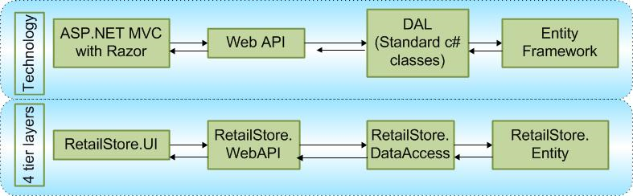

|  |  |  |
| --- | --- | --- |
| **Project Name** | **File** |  |
| RetailStore.UI | RetailStore\Views\Home\ Index.cshtml | ASP.NET MVC project with a sample screen named Index. Using JQuery and Ajax, request are made to ProductsController of RetailStore.WebAPI. For example :- api/products/5 |
|  | HomeController.cs | This controller is used only to render page. |
| RetailStore.WebAPI | ProductsController.cs | ProductsController web API is used to retrieve a product or multiple products. This web API interacts with data access layer and returns data. |
|  | CategoryController.cs | This web API is used to retrieve product with filter by category. |
|  | \Common\AutoMapperBoot Strapper.cs | AutoMapper library is used to map one object to another. |
|  | \Common\ GlobalExceptionHandler.cs | Log or handle errors globally. |
| RetailStore.DataAccess | ProductRepository.cs | Data Access layer interacts with RetailStore.Entity objects. |
|  | \Common\DataAutoMapper.cs | AutoMapper library is used to map one object to another. |
| RetailStore.Entity | RetailStore.edmx | Entity Framework talks to the database. |
| RetailStore.Database | \Scripts | .SQL files of Store procedures |
|  | RetailStoreDB.mdf | SQL database file. |
|  | RetailStoreDB.ldf |  |
| RetailStore.Common Library | AppConfig.cs | To read settings from config file. |
|  | AppLog.cs | It’s just a simple class file to write log to a physical file. |
| UnitTest.RetailStore. Entity | ProductEntityUnitTest.cs | Unit test case for Entity objects. |
| UnitTest.RetailStore. WebApi | ProductControllerUnitTest | Unit test case for product web api. |

**Configuration File info**

|  |  |  |
| --- | --- | --- |
| Setting Name |  |  |
| RetailStoreEntities | <add name="RetailStoreEntities" connectionString= "provider= System.Data.SqlClient;provider connection string=&quot;Data Source= (LocalDB)\v11.0;AttachDbFilename=C:\Projects\Product\Database\RetailStore.Database\RetailStoreDB.mdf;Integrated Security= True;multipleactiveresultsets =True;application name= EntityFramework&quot;" providerName= "System.Data.EntityClient" /> | SQL database connection string. This connection string is using AttachDbFilename=”C:\Projects\ Product\Database \RetailStore.Database \RetailStoreDB.mdf”. Set the correct path before you run this project. |
| ErrorLogPath | <add key="ErrorLogPath" value="C:/temp/" /> | Log file will be generator in this path. |
| LogFileName | <add key="LogFileName" value="WebErrorLogDebug" /> | Log file name. |
| RetailStoreWebAPIHost Address | <add key="RetailStoreWebAPIHostAddress" value="http://localhost:25445/" /> | URL of web API. |